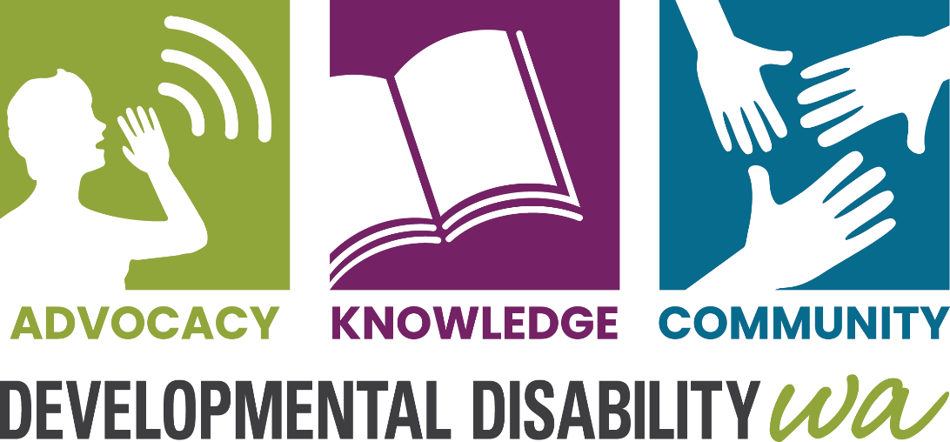
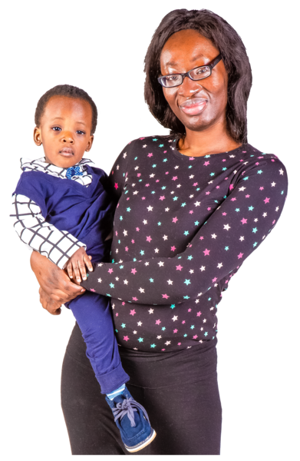

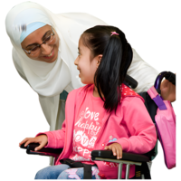
We help people who were born with a disability and their families

They could have intellectual disability, global developmental delay, Autism, cerebral palsy, ADHD or some other developmental disability.
There is often no reason why the person has the disability and nothing that parents could have done to stop their child having a disability.


How we can help you

Information – You can phone us to get information about disability services and other support for you and your child. We can arrange an interpreter.

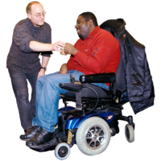
Advocacy - We can help you find an advocate. An advocate is a person you can trust and can help you to speak up when something is wrong. We have an advocate who helps parents when their child is having problems at school.


Support – We help parents when their child has disability and challenging behaviour. We help parents to find services that help them understand what is causing the behaviour and what are good ways to respond.


NDIS Support Coordination – We help people who have a NDIS plan
- to get the services they need
- to make the most of their plan
We have staff who speak Chinese, Hindi, Malay, Malayalam, Ndebele, Shona, Spanish, Tamil and Zulu. We can use the Telephone Interpreter Service (TIS) using your NDIS number.

How you can contact us

Phone: 9420 7203
Email: ddwa@ddwa.org.au
Web: www.ddwa.org.au
Address: Developmental Disability WA
City West Lotteries House
2 Delhi Street
West Perth 6005
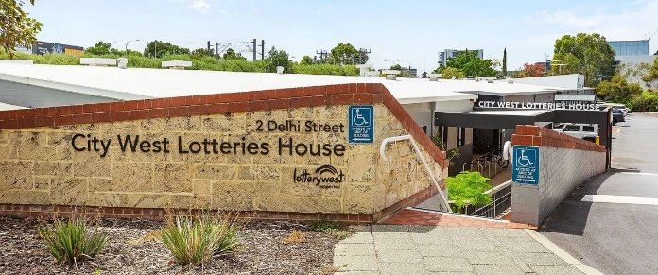
Train: City West stop
on Fremantle line
CAT Bus: Green and Yellow CATs,
Harold Boas Garden stop
Become a Member of DDWA it is free!

