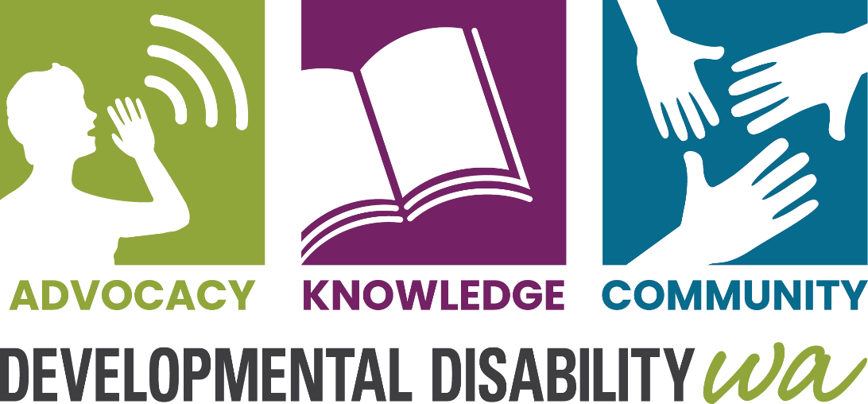
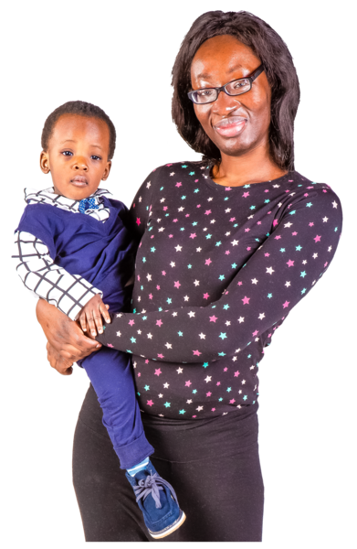

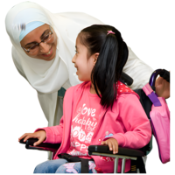
Sisiza abantu abazalwa nokukhubazeka kanye nemindeni yabo

Bangaba nokukhubazeka kwengqondo, ukubambezeleka kokukhula jikelele, i-Autism, i-cerebral palsy, i-ADHD noma olunye uhlobo lokukhubazeka kokukhula. Kuvamise ukuthi kungabi nesizathu esicacile sokuthi umuntu abe nokukhubazeka, futhi akukho lutho abazali abangabe belwenzile ukuvimbela ukuthi ingane yabo ibe nokukhubazeka.


Singakusiza kanjani

Ulwazi – Ungasishayela ucingo ukuze uthole ulwazi ngezinsiza zokukhubazeka kanye nokunye ukwesekwa kwakho nengane yakho. Singahlela umhumushi.

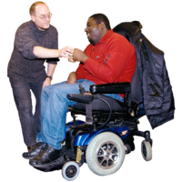
Ukumela - Singakusiza ukuthola umuntu ozokumela. Ummeleli ngumuntu ongathembela kuye, ongakusiza ukukhuluma uma kukhona okungahambi kahle. Sinomuntu omelela abazali lapho ingane yabo ibhekene nezinkinga esikoleni.

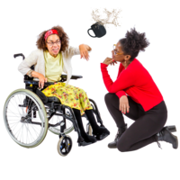
Ukusekelwa – Sisiza abazali lapho ingane yabo inokukhubazeka kanye nokuziphatha okuyinselele. Sisiza abazali ukuthola izinsiza ezibasizayo ukuqonda ukuthi yini ebangela lokhu kuziphatha nokuthi yiziphi izindlela ezinhle zokuphendula.


Ukuxhaswa kwe-NDIS – Sisiza abantu abanohlelo lwe-NDIS
- Ukuthola izinsiza abazidingayo
- ukusebenzisa kahle uhlelo lwabo
Sinabasebenzi abakhuluma isi-Arabic, isi-Dinka, isi-Hindi, isi-Mandarin, isi-Malay, isi-Malayalam, isi-Pidjin (Creole), isi-Shona, isi-Spanish, isi-Swahili nesi-Tamil. Singasebenzisa i-Telephone Interpreter Service (TIS) sisebenzisa inombolo yakho ye-NDIS.

Ungasithinta kanjani

Ucingo: 9420 7203
I-imeyili: ddwa@ddwa.org.au
Iwebhu: www.ddwa.org.au
Ikheli: Developmental Disability WA
City West Lotteries House
2 Delhi Street
West Perth, 6005
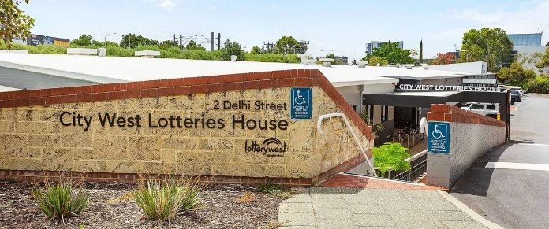
Isitimela: Isiteshi i-City West
ku-Fremantle Line
Ibhasi le-CAT: Ama-CAT aluhlaza noluphuzi, isiteshi
i-Harold Boas Garden stop
Yiba yilungu le-DDWA – kumahhala!

