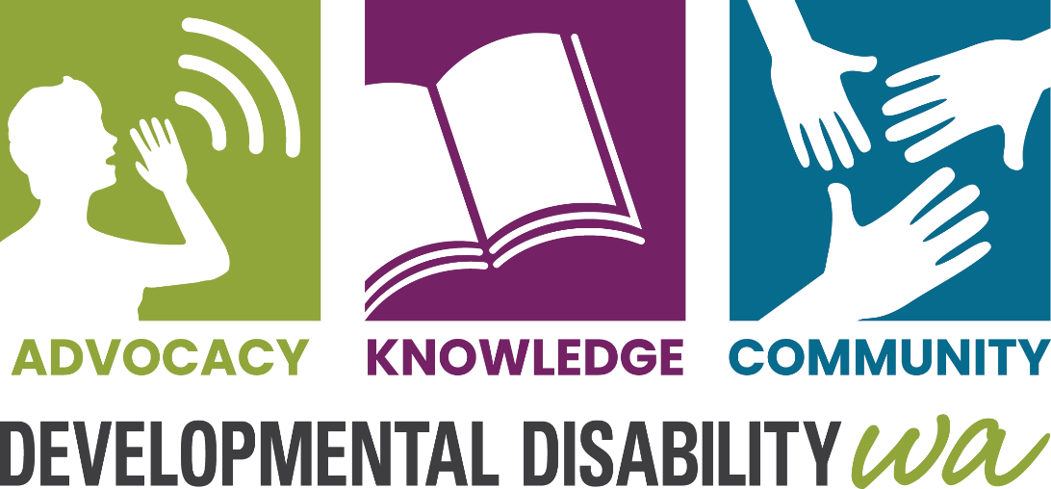
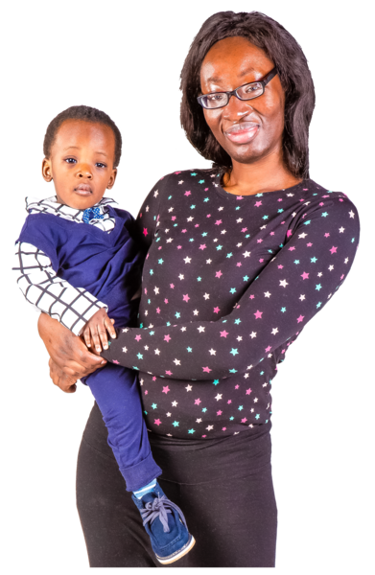

Siyanceda abantu abazalwa bekhubazekile kanye lemindeni yabo

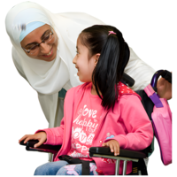
Bangaba lokukhubazeka kwengqondo, ukubambezeleka kokukhula emhlabeni wonke, i-Autism, i-cerebral palsy, i-ADHD kumbe okunye ukukhubazeka kokukhula.
Kuvamile ukuthi kungabi lasizatho esicacileyo sokuthi umuntu abe lokukhubazeka, njalo akukho lutho abazali ababengalwenza ukuvimba ukuthi umntwana wabo abe lokukhubazeka.


Singalinceda njani

Ulwazi – Ungasifonela ukuze uthole ulwazi ngezinsiza zabakhubazekileyo kanye lokunye ukusekelwa kwakho lomntwana wakho. Singakuhlela umhumushi.

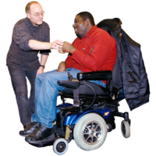
Ukumelwa - Singasinceda ukukutholela ummeli. Ummeli ngumuntu ongamthemba ongakusiza ukukhuluma nxa kukhona okungahambi kuhle. Silemela osiza abazali lapho umntwana wabo elezinkinga esikolo.

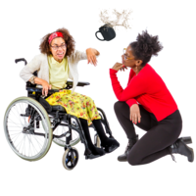
Ukusekelwa – Siyasiza abazali lapho umntwana wabo elekhubazeko kanye lokuziphatha okunzima. Siyasiza abazali ukuthola izinsiza ezibanceda ukuqonda ukuthi kuyini okubangela lokhu kuziphatha lokuthi yiziphi indlela ezingcono zokuphendula.

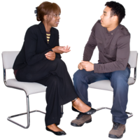
Ukuxhaswa kwe-NDIS – Siyasiza abantu abalohlelo lwe-NDIS
- Ukuthola izinsiza abazidingayo
- Ukusebenzisa kahle uhlelo lwabo
Silabasebenzi abakhuluma isi-Arabic, isi-Dinka, isi-Hindi, isi-Mandarin, isi-Malay, isi-Malayalam, isi-Pidgin (Creole), isi-Shona, isi-Spanish, isi-Swahili kanye nesi-Tamil. Singasebenzisa i-Telephone Interpreter Service (TIS) sisebenzisa inombolo yakho ye-NDIS.

Ungasithinta njani

Ucingo: 9420 7203
I-imeyili: ddwa@ddwa.org.au
iwebhu: www.ddwa.org.au
Ikheli: Developmental Disability WA
City West Lotteries House
2 Delhi Street
West Perth, 6005
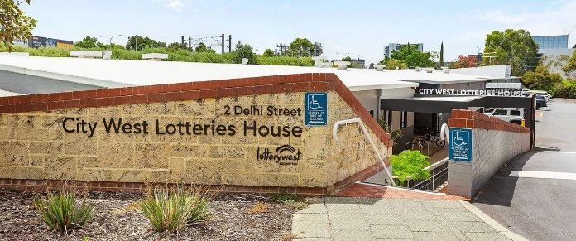
Isitimela: Isiteshi i-City West
ku-Fremantle Line
Ibhasi le-CAT: Ama-CAT aluhlaza noluphuzi, isiteshi
i-Harold Boas Garden stop
Yiba yilungu le-DDWA – kumahhala!

