

People with
high needs living with
intellectual disability

Summit Report

22 March 2024

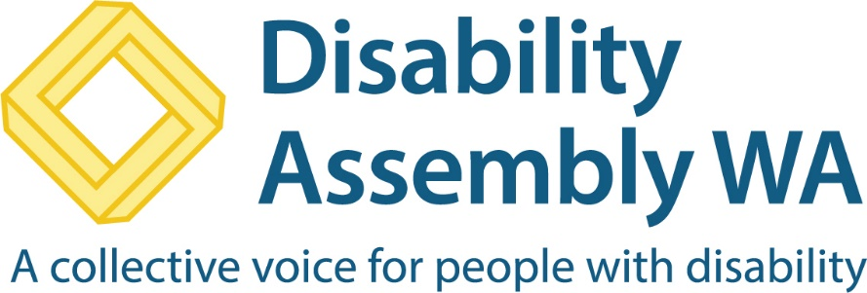

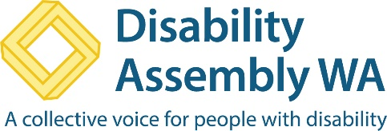
Disability Assembly WA is also called DAWA. DAWA wrote this book.
When we say we it means DAWA.

Assembly means all kinds of people who come together.

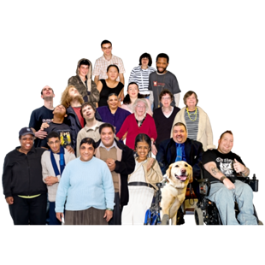

We held a summit. A summit means a big meeting where a lot of people talk about a shared problem together.

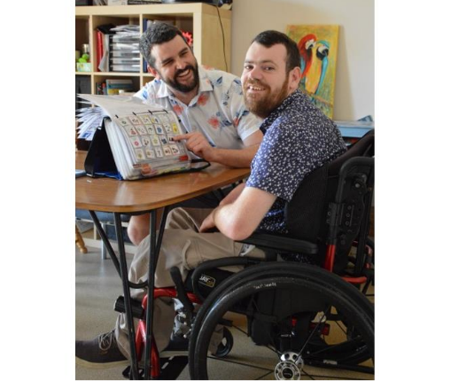
The summit was to talk about people with intellectual disability who have high needs. High needs means someone who needs a lot of help all the time.

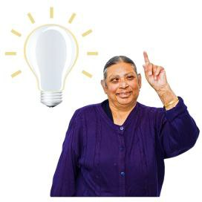

This is a short report of our ideas from the summit.



The summit was in Wembley on 22 March 2024

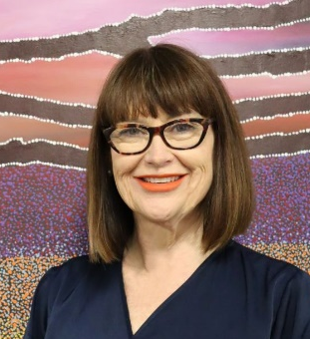
Doctor Sarah Love said welcome to everyone who came to the summit. Sarah runs DAWA.

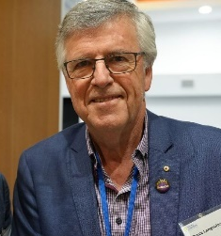
Bruce Langoulant spoke about why DAWA started. He is the Chairperson which is like the big boss.

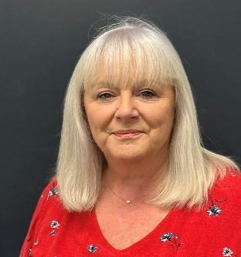
Leticia Grant spoke about her life as a mum of someone who needs a lot of help.

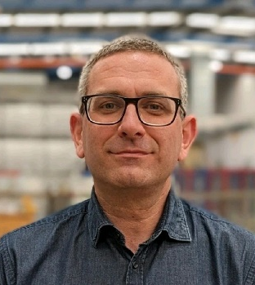
Tom Tolchard was the summit leader. He asked us to split up into three groups called Pods.

In each Pod we talked about

- having a good life


- having a good home


- having people who love and care about you so that you feel safe.


We came up with 18 things that need to be made better.

- Support Workers need to
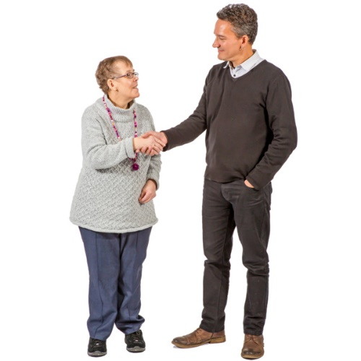
  - be respected for the work they do


  - know they can have a job for a long time

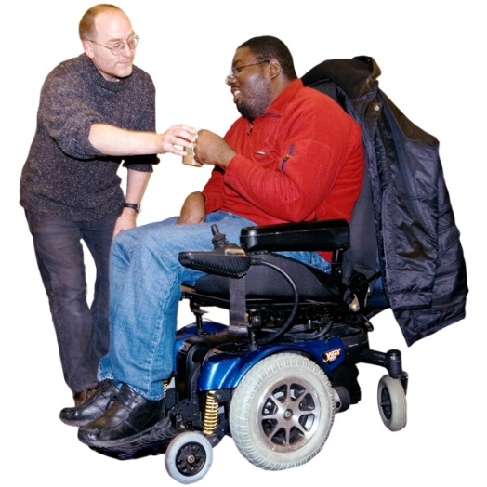
  - be paid more as they learn new skills


- Support Workers need

  - more time for helping people with disability


  - less time for doing jobs cleaning the house


  - more time to learn things like helping people with disability to speak up

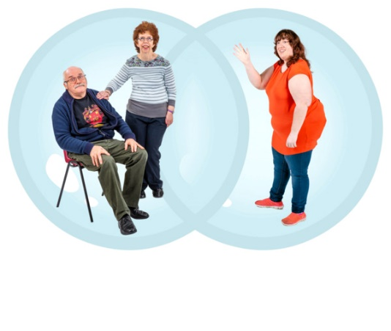
3. Families need more respite. Respite means having a break from looking after someone all the time.


  - Families who look after people with high needs want different types of respite.

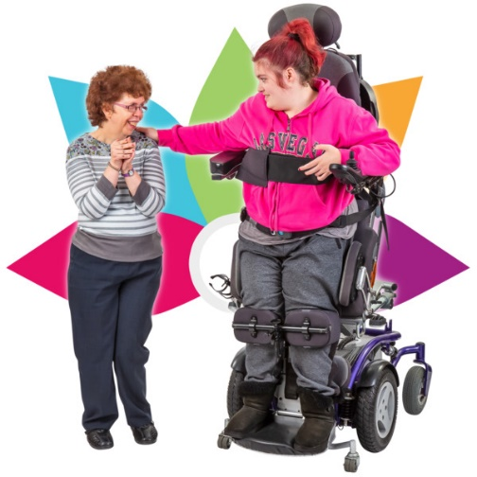
  - Not many places to get respite when a person has high needs.

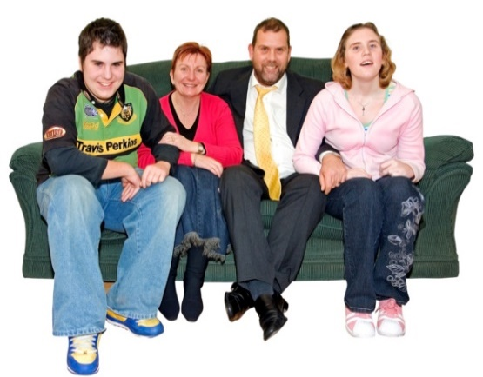
- There is less help now for families who look after someone with high needs.

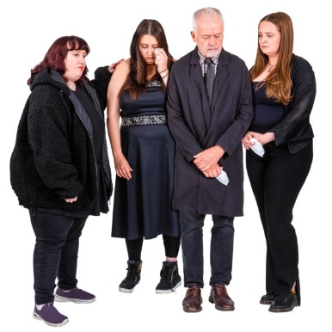
        - Parents worry a lot about who will look after their son or daughter when they die.


- Families want to make sure the plans they make will still happen after they have died.


- Families want to feel sure that someone will care like they do.

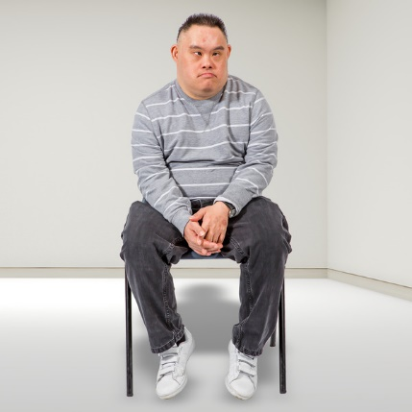
        - There is a lot of worry about people who do not have family to make sure they are OK.


6. There are a lot of changes to the rules about what help people can get. It is really hard for families to understand all of these rules.


- The rules should not change when the government changes after an election. An election is when everyone votes who they want to run Australia.


- No one in government has the job to make sure people with high needs get the help they need.

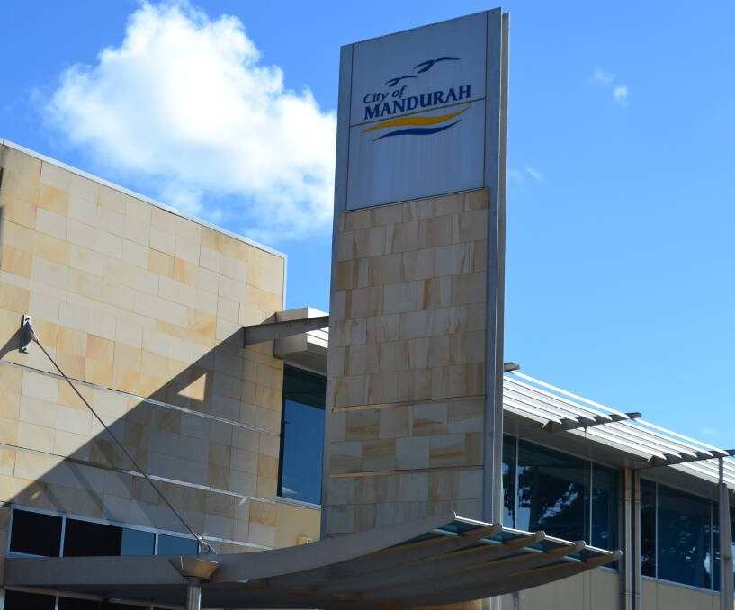
- Only some local governments are making things better for people with high needs. Local governments are the people who look after services near to where you live. Things like rubbish pools gyms and libraries.

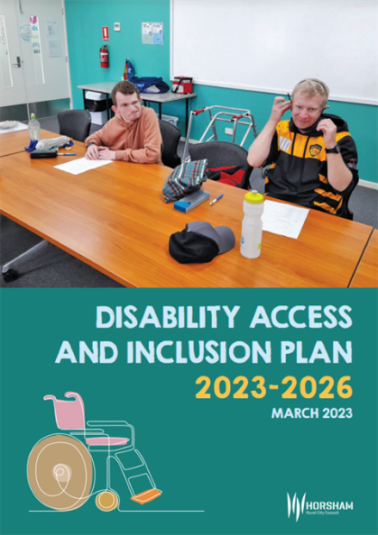
- Not all local governments are doing a good job with their Disability Access and Inclusion Plans. These plans are called DAIPs for short. DAIPs are things that governments are doing to make things better.

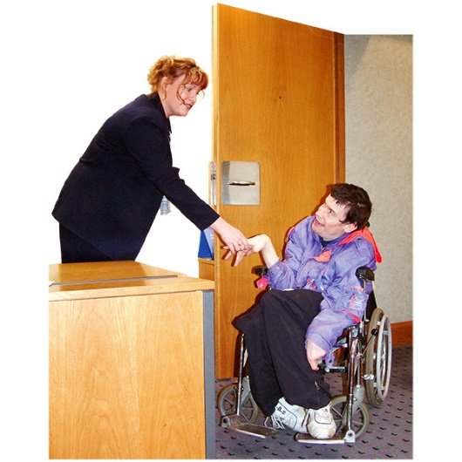
- Lots of places and things are still not accessible for people with intellectual disability. Accessible means that a person with disability can go to a place and use all the services.

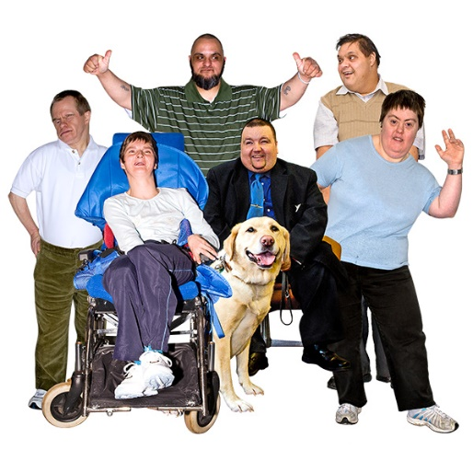
10. There needs to be a lot more places in the community that welcome all people with disability.

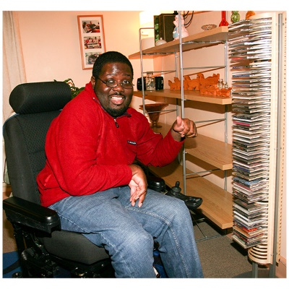
11. Lots of people with high needs still live at home with their parents. Some want a place of their own where they can get help anytime.


12. Schools need to do a lot more staff training about all kinds of disability and how to listen to students.

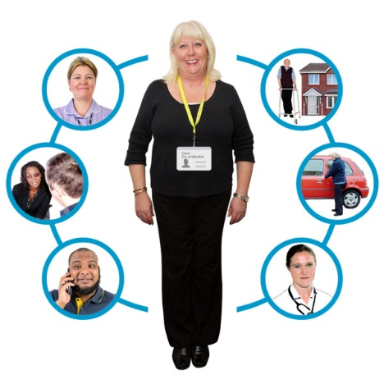
13. Families want one person to go to for help. It is too hard having to explain things to lots of new people all the time.

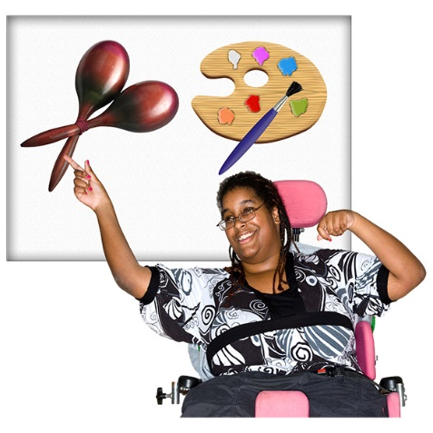
14. There needs to be better help for students and their families when planning what to do after school. Things like

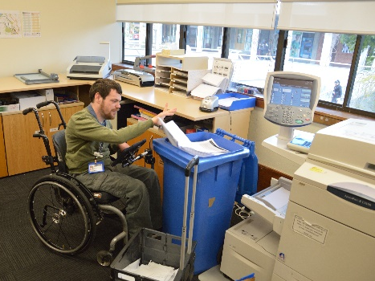
- Getting a job

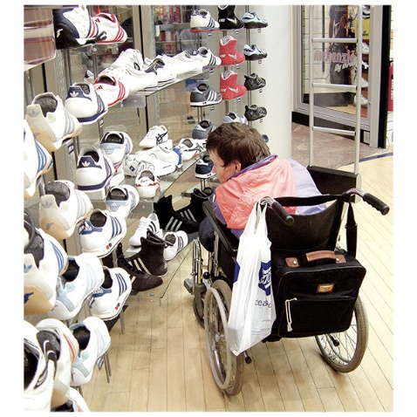
- Being part of the community

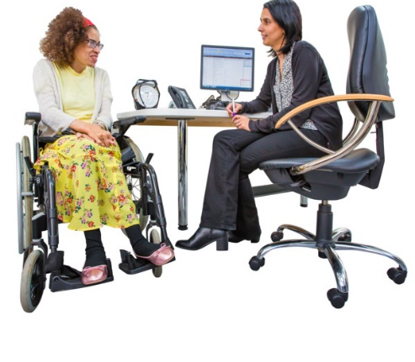
15. It is harder for people with high needs to get good health care. Lots of health staff need to learn how to help people with high needs.


- People need the same or more support worker help when they are in hospital.

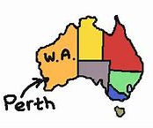
16. For people who live outside of Perth there are lots of extra problems like


- Not much choice of good services.

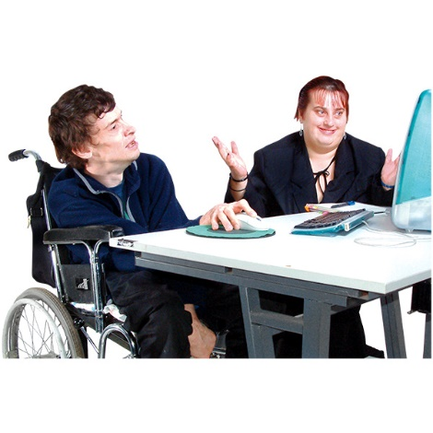
- Mobile phones and computers do not always work. It is harder to get online help.

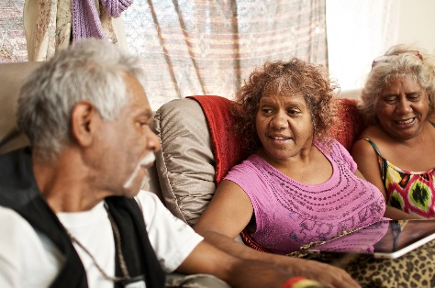
- Staff who work with aboriginal people need to learn about their culture. Culture means the history and other things that are important to a group.

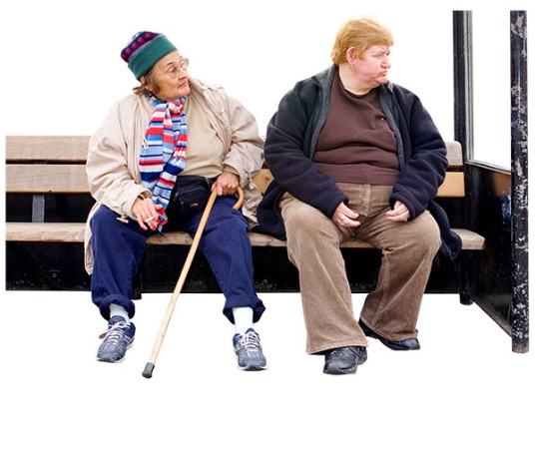
17. There are lots of transport problems for people who live outside of Perth like


- Not many places have wheelchair accessible taxi’s.

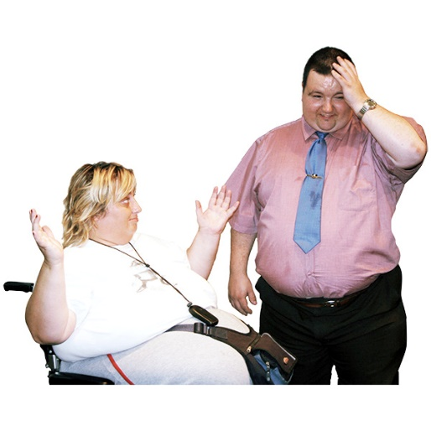
Not much help at airports

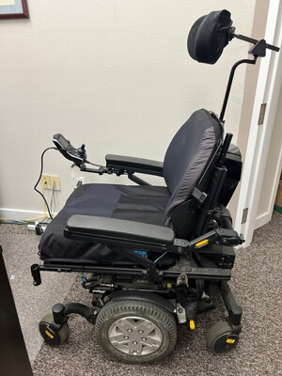
- Wheelchairs get broken when being sent to country areas.

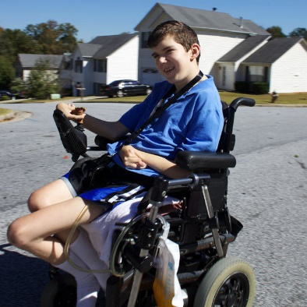
18. Young people with high needs have to stay in nursing homes and hospitals. This costs a lot more than building the right kind of house near family.

At the end of the summit, Bruce Langoulant from DAWA, said a big thankyou to everyone who came along.

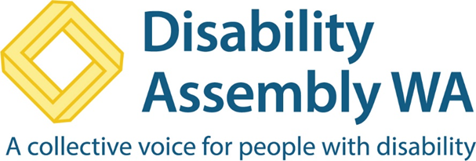

www.disabilityassemblywa.org

This report was made into Easy Read by Developmental Disability WA

