What to do if you have been scammed


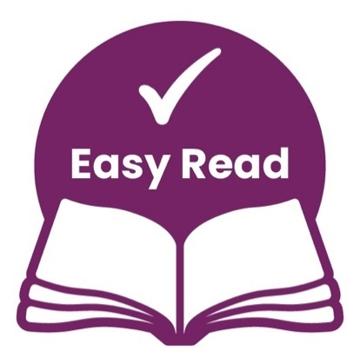
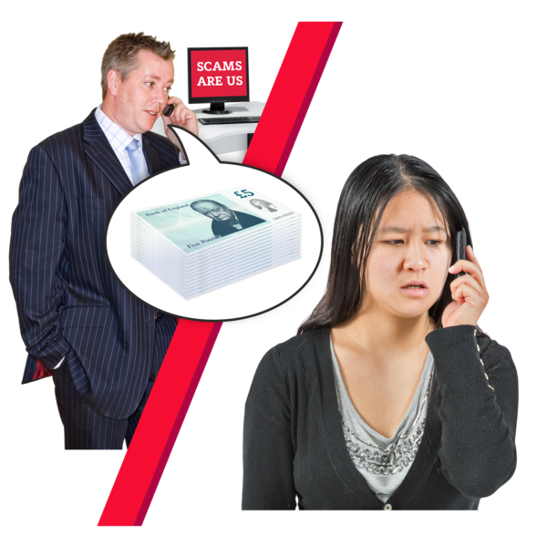
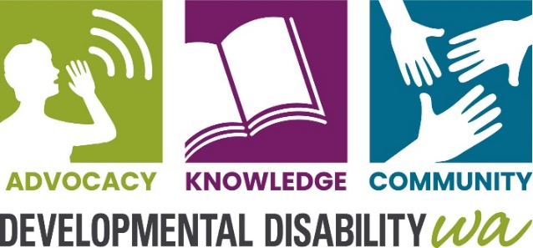
About this book
www.ddwa.org.au
web address
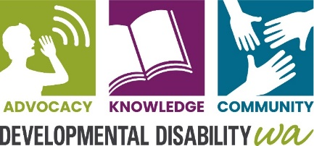
This book is written by Developmental Disability WA. When you see the word we it means Developmental Disability WA.

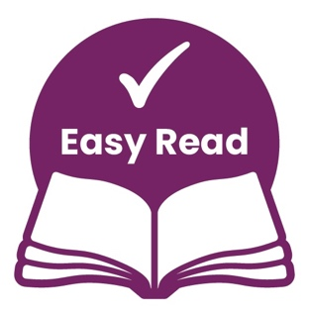
This book is written so it is easy to read. The first time we use hard words we write them in blue. Then we explain what the word in blue means.

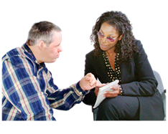
You can get someone to help you:
- read this book
- know what this book is about.


You can ask for more information.

What is a scam?
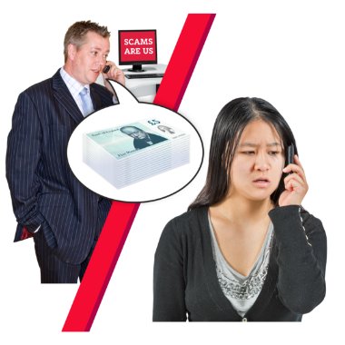
We call it a scam when someone tries to-

- trick you
- take your money
- get your personal information


A scammer is someone who does a scam.


If you have been scammed it is important you tell someone

There are people that can help you


Scammers might take money from your bank account. If this happens call your bank.

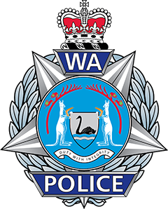
You should report all crime to WA Police. You can call the Police Assistance Line on 131 444. You can go to your local Police station.


WA ScamNet want you to report any scams to them. You can call the Consumer Protection Contact Centre: 1300 304 054


The Australian Competition and Consumer Commission or ACCC
The Australian Competition and Consumer Commission or ACCC keep consumers safe.
Consumers are people who buy things. You can call the ACCC 1300 302 502

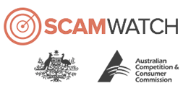
The ACCC have a website called Scamwatch. Scamwatch is a website to help you see scams and avoid them. Go to their website www.scamwatch.gov.au

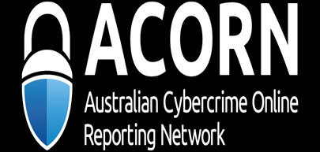
Australian Cybercrime Online Reporting Network or ACORN.

You can report Cybercrime.
ACORN do not have a phone number. Go to their website www.acorn.gov.au


Cybercrime is a crime which uses computers and the internet. This could be breaking into your computer system and email scams.

Contact Us
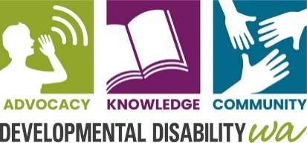
DDWA


(08) 9420 7203


City West Lotteries House
2 Delhi Street, West Perth

ddwa@ddwa.org.au

www.ddwa.org.au


facebook.com/DDCofWAInc/


Instagram.com/ddwa

This booklet was made by the Council on Intellectual Disability NSW and updated by Developmental Disability WA using images from Freepik.com

