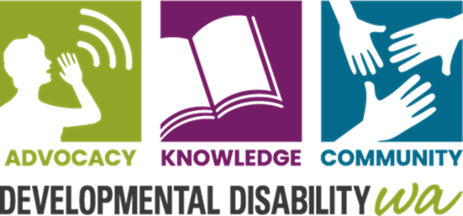
Developmental Disability WA

Becoming a Member
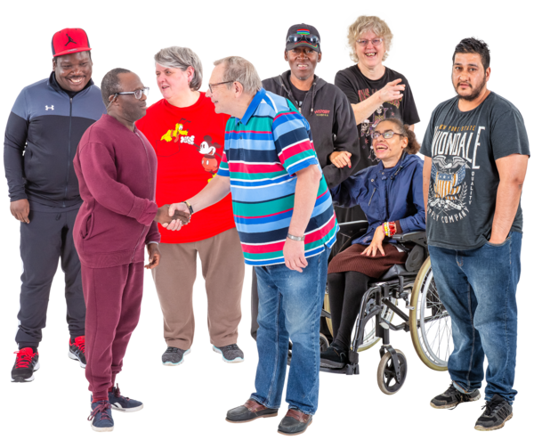
Completing the form on page 3 means you want to become a member of Developmental Disability WA (DDWA).

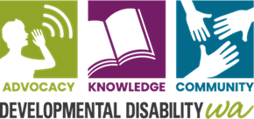
What is DDWA?
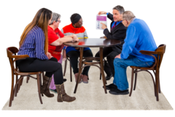
DDWA is an organisation that supports people with developmental disabilities, their families and carers.
Organisation means a group of people who work together.

You can find more information about DDWA on our website at www.ddwa.org.au
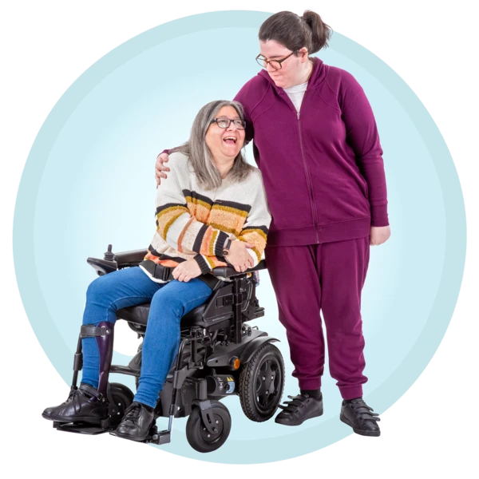
Membership means you are part of a group of people who are interested in the things DDWA does, and you can have your say.

Being a member gives you access to
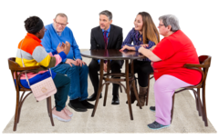
- Information
- Invitations to workshops and discussion groups
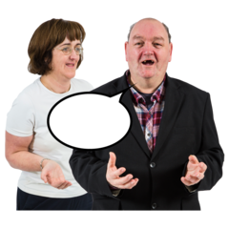
- Advocacy - An advocate can help you speak up for your rights.
- Connection to a community group of people who want action on similar issues.
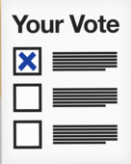
- You can also vote at our Annual General Meeting and have your say on other issues.

Membership form

Your First Name: ___________________________

Your Last Name: ___________________________

Your Address: where you live – Number, Street name and Suburb/Town
_________________________________________________________

Your postcode: __________________________

Your email:

Phone number:

Your Date of Birth: __ __ / __ __ / __ __ __ __
Day Month Year

Post or give this form to:
DDWA
City West Lotteries House,
2 Delhi Street, West Perth WA, 6005

Or email to
ddwa@ddwa.org.au

Please tick what things you are interested in on the next page.
What Are You Interested In? Please tick.
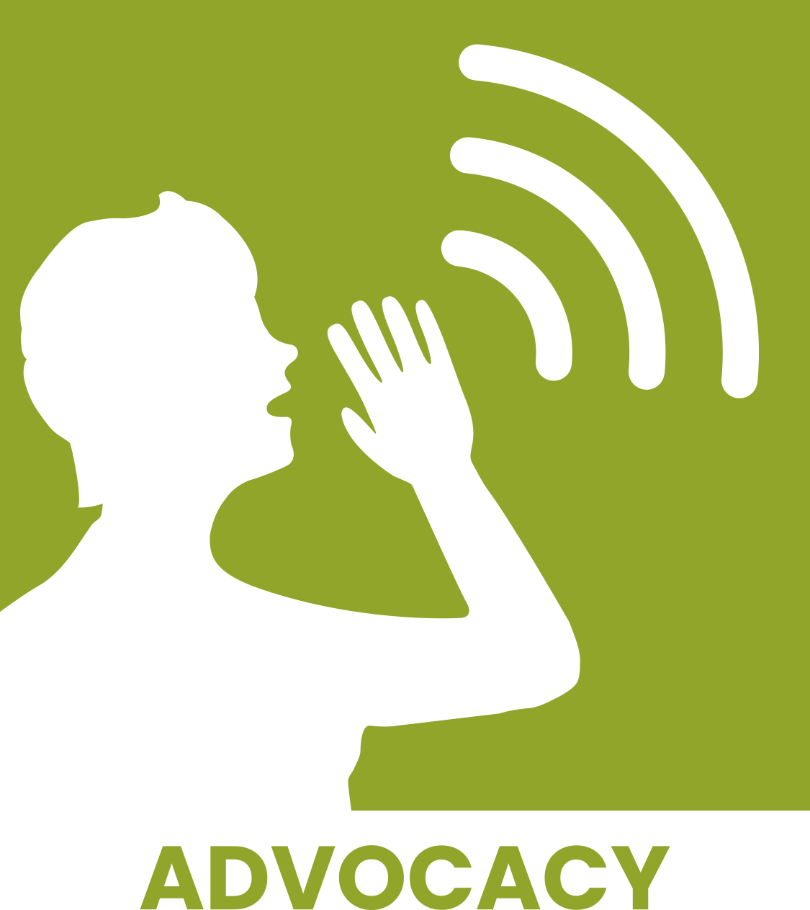
Advocacy - someone to help you speak up for your rights
Employment – having a job

Health

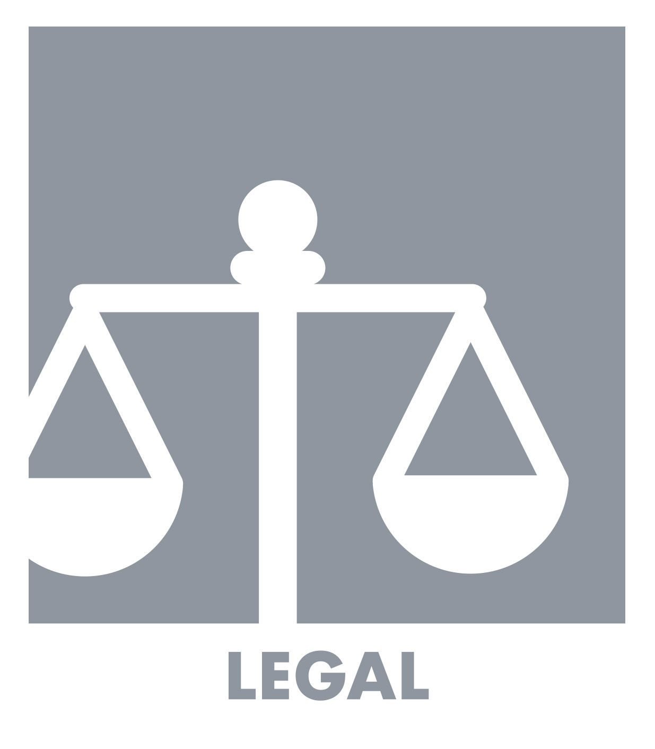
Legal

Relationships

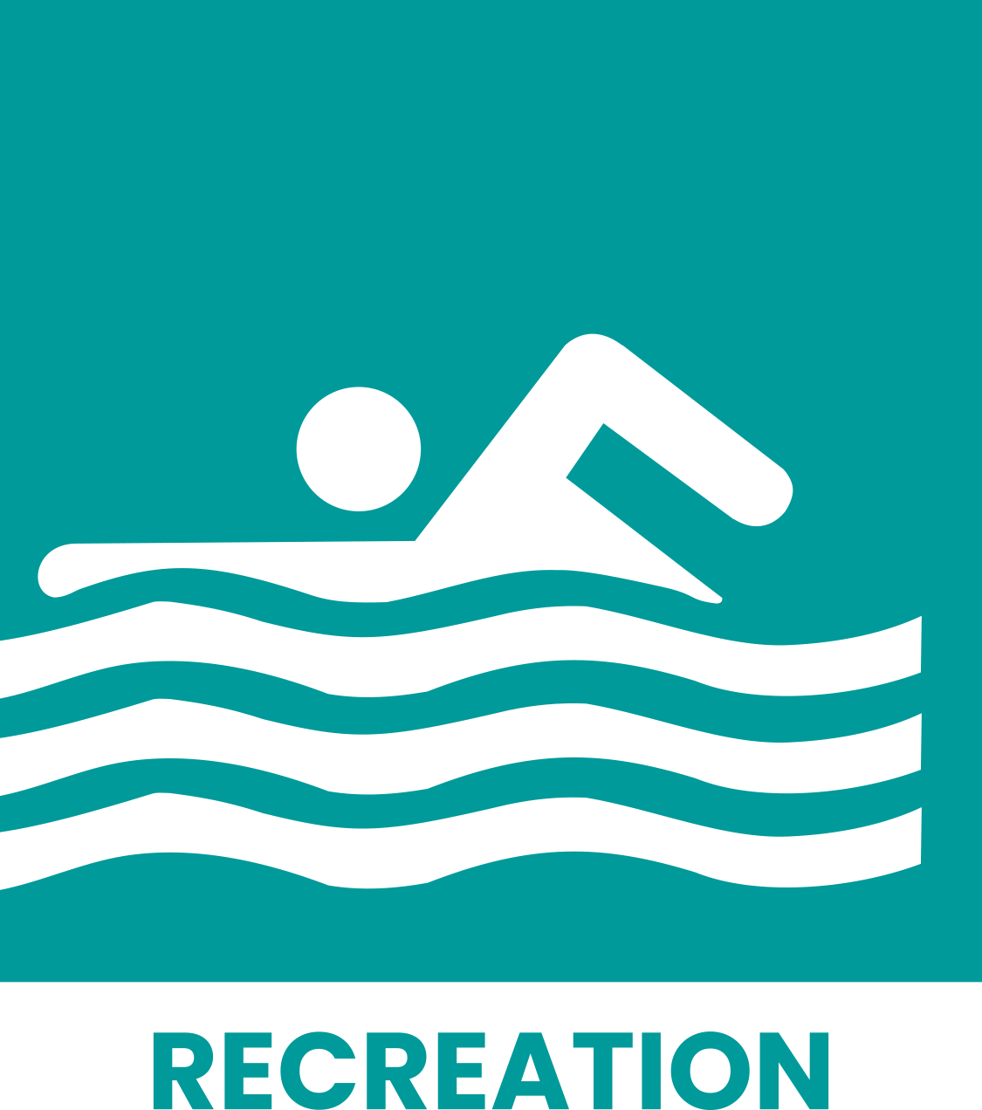
Recreation – sport, clubs

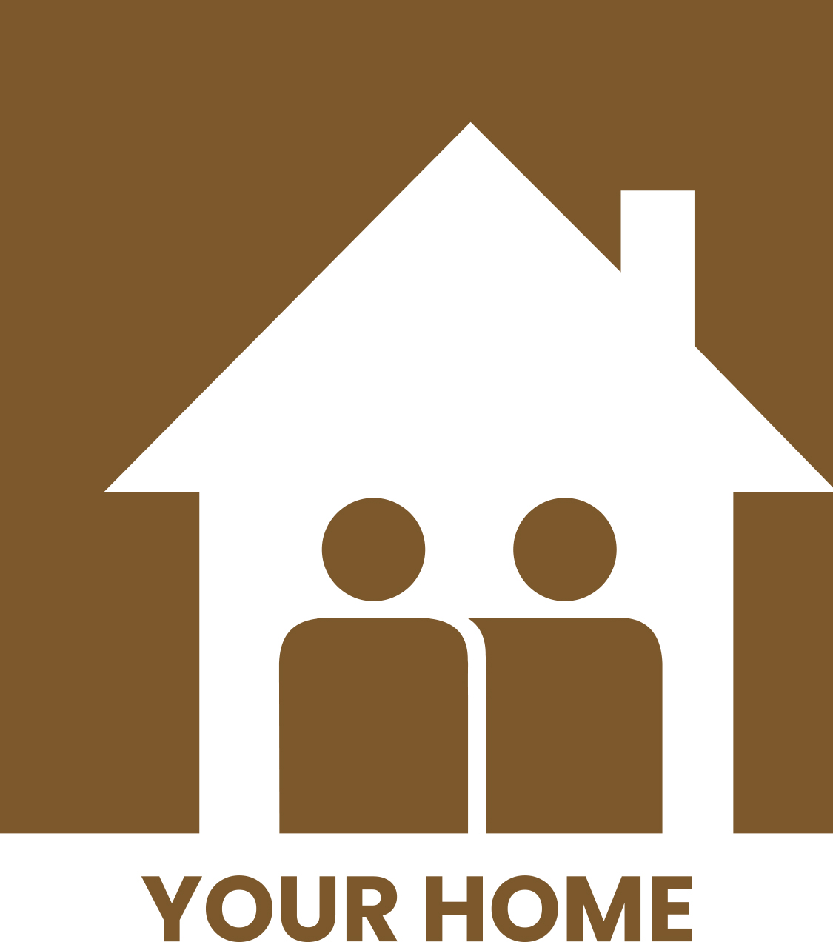
Your home, where you live
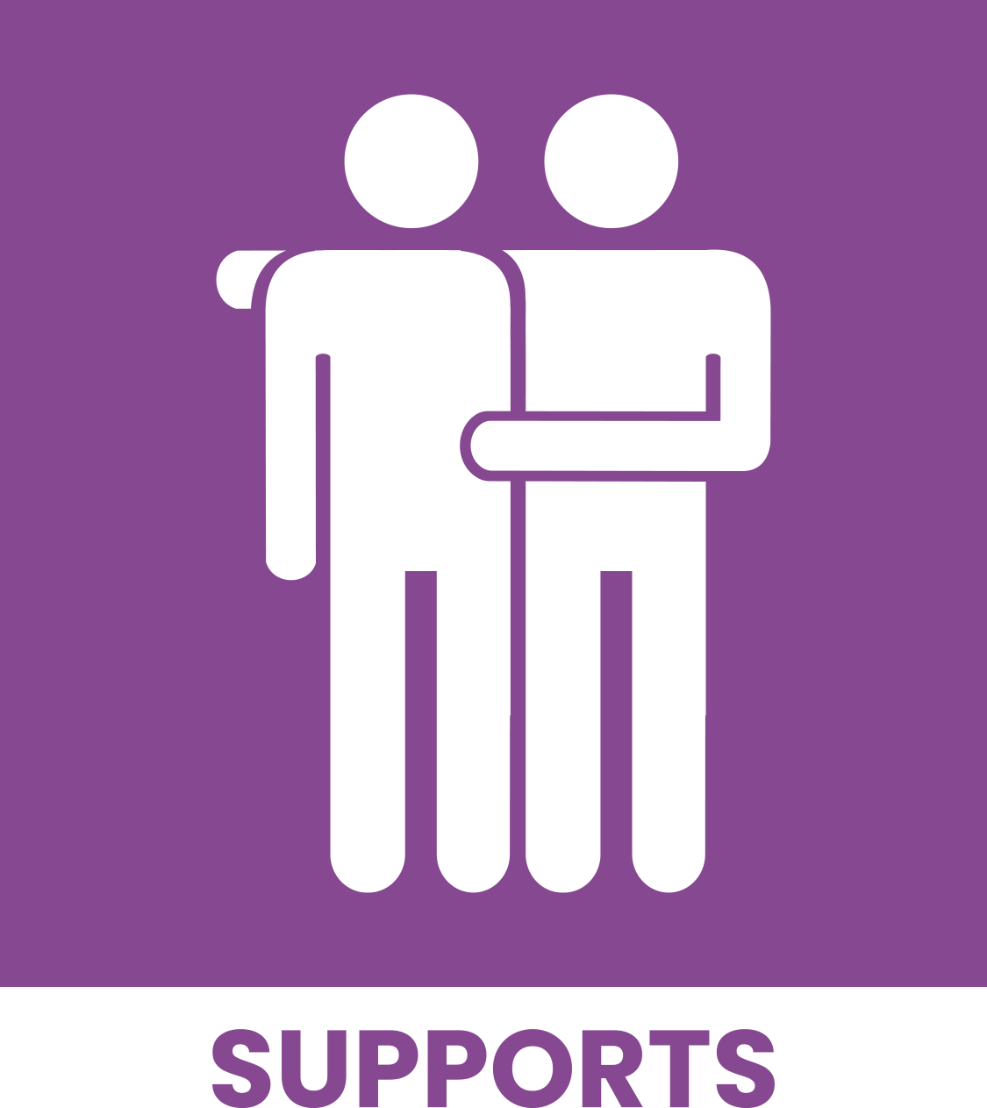

NDIS or Other Supports

