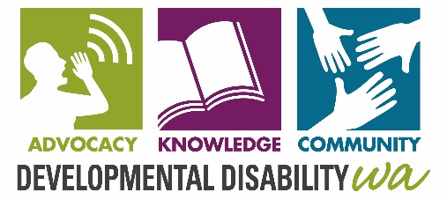
Face Covering Exemption Cards

On 31st January, 2021 the Government of Western Australia made a new rule.

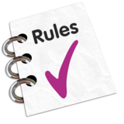
The rule is part of the Emergency Management Act of Western Australia.

The new rule is to help stop COVID-19 spreading.

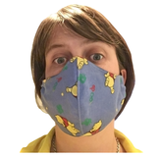
The rule is that everyone must wear a mask that covers their mouth and nose when they are outside their home.

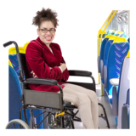
Some people do not have to follow this rule.

The Emergency Management Act says these people do not have to wear a mask:

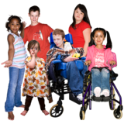
- Children under 12 years old

- People who have a medical condition that makes wearing a mask difficult or dangerous

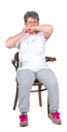
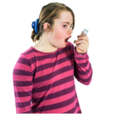
- People who have a disability that makes wearing a mask difficult or dangerous

- People who have a mental illness that that makes wearing a mask difficult or dangerous

Some people do not know that it is OK for some people not to wear a mask.

We are sharing these cards, made by photosymbols.com for keepsafe.org.uk to help you when people ask why you or your loved one is not wearing a mask.

You can show the card to tell someone quickly that you have a legal reason not to wear a face mask.

You can print these cards and you or your support person can

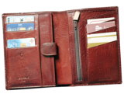
keep them in a wallet,

wear them on a lanyard,

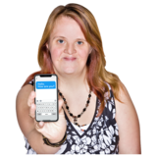
or keep them as photos on your phone ready to show other people.

