# You’re invited to join us on

The Couch

**To learn basic first aid with this**

**First Aid course devised for People with a developmental disability.**

**DDWA are subsidizing this course so the cost per student**

**is just $50 for 2 sessions.**

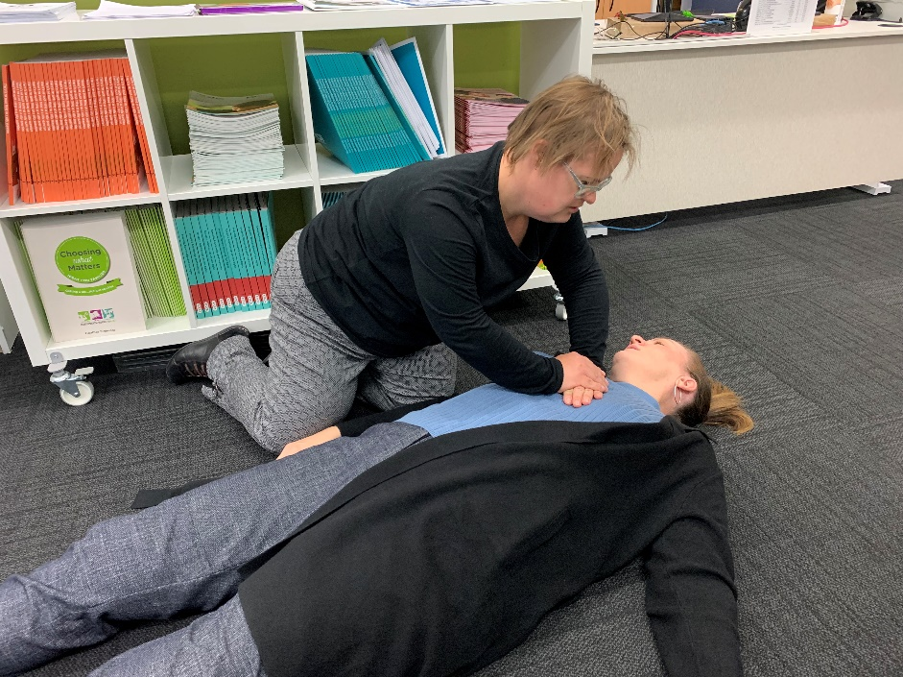

At these two sessions we are going to learn about:

* June 8th Session 1 –

Danger, Response, Send for help, Airway, Breathing, Cardiopulmonary resuscitation and Defibrillation, Legal, Recovery Position, CPR adult and infant, Defibrillation

* June 15th Session 2 –

Basic First aid - Asthma, Choking, Allergies, Bleeding management, Epilepsy,

Diabetes, Snake bites

At the end of this non-accredited course (you will need to attend both weeks) you will get a certificate in

**Concepts and Practice of First Aid Skills**

This Couch session is being hosted by Dr Kumar Goteti, a medical doctor and

First Aid Trainer with experience in disability

Tuesday 8th and 15th June 3.00PM- 6.00 PM

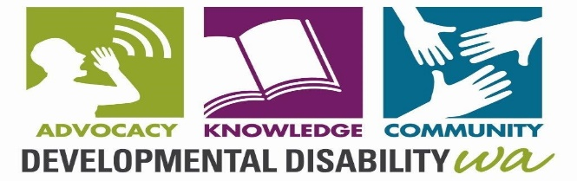

## Who is invited? People 18 years and over with intellectual disability with a support person to assist if needed



**More Information: Leticia Grant**

**9420 7230**

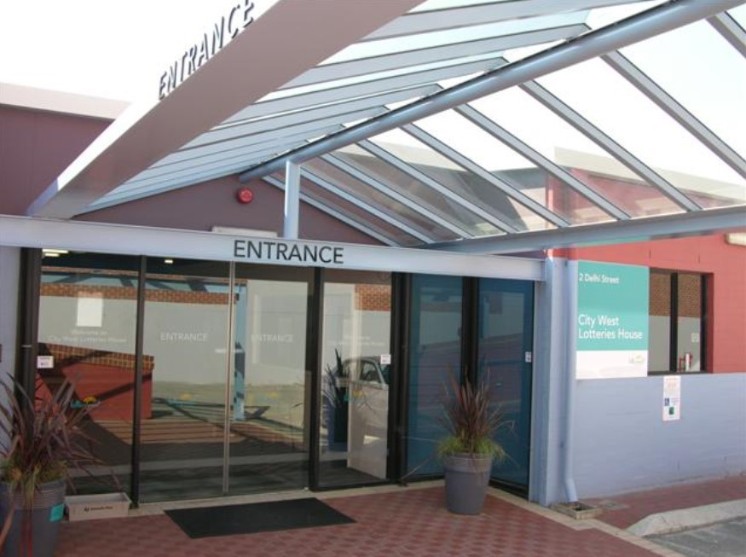

**Where : Conference Room, Lotteries House,**

**2 Delhi Street, West Perth**

**Getting There: Train—**

**City West stop Fremantle line Free car parking**



**Food and drinks provided. Tell us if you have a special diet**

**This Couch session has been co-funded by the NDIS—Information, Linkages & Capacity Building program**

**You can also book online: https://www.eventbrite.com.au/o/developmental-disability-wa-2046684199**